Homework 3 (25 points)

1. **B+ Tree (8 points)**

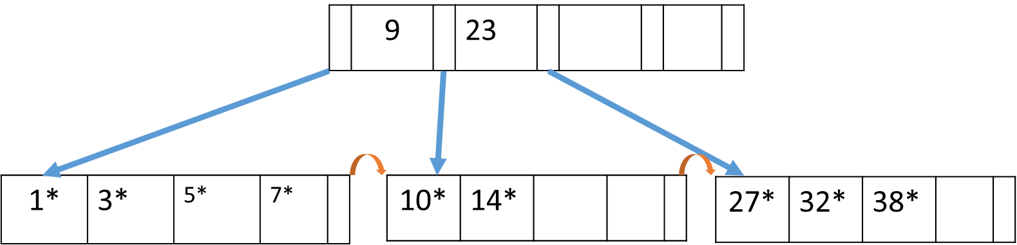

Assume the following B-tree exists with d = 2:

Draw the B+-tree after each step in the following sequence of insertions and deletions:

Insert 28, Insert 4, Delete 38, Delete 14, Delete 7

**Note:** Please use the insertion and deletion algorithms given in the lecture slides.

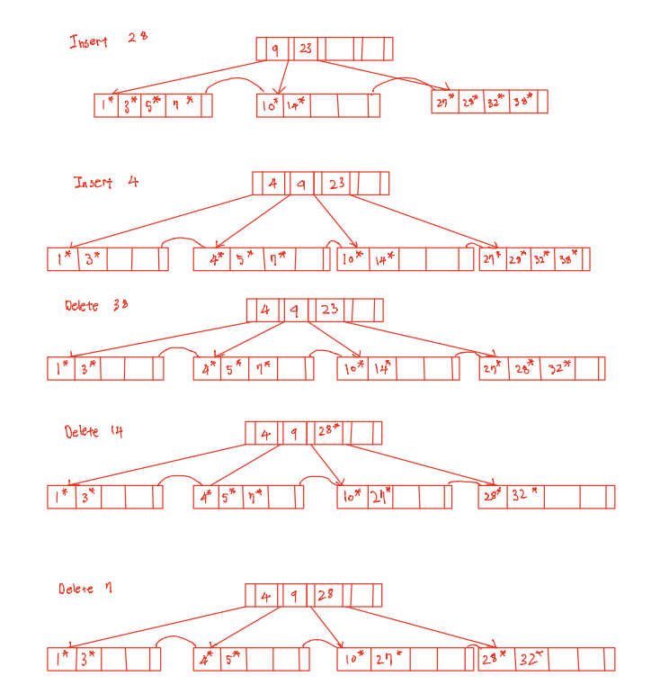

1. **Disk, File Storage and Organization (8 points)**

Consider a disk with a sector size of 512 bytes, 2000 tracks per surface, 50 sectors per track, five double-sided platters, and average seek time of 10 msec.   
Suppose also that a block size of 1024 bytes is chosen.   
Suppose that a file containing 100,000 records of 100 bytes each is to be stored on such a disk and that no record is allowed to span over two blocks.   
The disk platters rotate at 5400 rpm (revolutions per minute).   
We can transfer one track per revolution.

* 1. How many records fit onto a block?

1024 bytes per block /100 bytes per record = 10.24 records per block  
10 records at maximum

* 1. How many blocks are required to store the entire file? If the file is arranged sequentially on the disk, how many surfaces are needed?  
     100,000 records in a file / 10 records per block =   
     10,000 blocks are required to store the file  
       
     2,000 tracks per surface * 50 sectors per track * 512 bytes per sector  
     = 51,200,000 bytes per surface  
     10,000 blocks per file * 1024 byes per block   
     = 10,240,000 bytes per file  
     10,240,000 bytes per file / 51,200,000 bytes per surface = 0.2 surfaces per file   
     = 1 surface is required to store the file
  2. How many records of 100 bytes each can be stored using this disk?  
     2,000 tracks per surface * 50 sectors per track * 512 bytes per sector   
     = 51,200,000 bytes per surface  
     Five double-sided platters = 5 * 2 surfaces  
     51,200,000 bytes per surface * 10 surfaces= 512,000,000 bytes per disk  
     10 records per block / 1024 bytes per block =  
     51,200,000 bytes per surface * 10/1024 record per byte = 5,000,000 records
  3. What is the transfer time if you are to read a file containing 100,000 records of 100 bytes each sequentially?  
     10,000 blocks per file * 1024 bytes per block = 10,240,000 bytes per file  
     50 sectors per track * 512 bytes per sector = 25,600 bytes per track  
     10,240,000 bytes per file / 25,600 bytes per track = 400 tracks per file  
     5400 revolutions per minute / 60 seconds per minute = 90 revolutions per second  
     400 tracks per file / 1 track per revolution = 400 revolutions per file  
     400 revolutions per file / 90 revolutions per second = 4.44 seconds to read a file

1. **Buffer management (9 points)**

Assuming that you have a four frame bufferpool. Please show the bufffer content given the workload listed in the table below using LRU and MRU strategies. We start from T1 and moves forward by one on each page reference. For your solution, highlight or cirle the frame in the bufferpool each time that a memory access caused a “miss” in the buffer pool (i.e., a page is read that is not currently in the buffer pool), when the page is put in the buffer pool. When the buffer pool has unused slots (such as at the beginning, when all four slots are empty), it will put newly read data in the first unused slot.  The pages to be read from disk are labelled A through G.  For each access the page is pinned, and then immediately unpinned. Assume one page on disk fits perfectly with one frame on the bufferpool.

|  |  |
| --- | --- |
| Time | Page Read |
| T1 | A |
| T2 | B |
| T3 | C |
| T4 | A |
| T5 | D |
| T6 | E |
| T7 | E |
| T8 | A |
| T9 | B |
| T10 | F |
| T11 | C |
| T12 | G |
| T13 | A |
| T14 | B |
| T15 | B |
| T16 | D |
| T17 | G |
| T18 | F |
| T19 | A |
| T20 | F |
| T21 | C |
| T22 | F |
| T23 | B |
| T24 | G |

Buffer Pool

LRU strategy

|  |  |  |  |  |  |  |  |  |
| --- | --- | --- | --- | --- | --- | --- | --- | --- |
| Time | Page Read | Frame 1 | Frame 2 | | Frame 3 | | Frame 4 | Queue |
| T1 | A | A |  | |  | |  | A |
| T2 | B | A | B | |  | |  | A b |
| T3 | C | A | B | | C | |  | A b c |
| T4 | A | A | B | | C | |  | B c a |
| T5 | D | A | B | | C | | D | B c a d |
| T6 | E | A | E | | C | | D | C a d e |
| T7 | E | A | E | | C | | D | C a d e |
| T8 | A | A | E | | C | | D | C d e a |
| T9 | B | A | E | | B | | D | D e a b |
| T10 | F | A | E | | B | | F | E a b f |
| T11 | C | A | C | | B | | F | A b f c |
| T12 | G | G | C | | B | | F | B f c g |
| T13 | A | G | C | | A | | F | F c g a |
| T14 | B | G | C | | A | | B | C g a b |
| T15 | B | G | C | | A | | B | C g a b |
| T16 | D | G | D | | A | | B | G a b d |
| T17 | G | G | | D | | A | B | A b d g |
| T18 | F | G | | D | | F | B | B d g f |
| T19 | A | G | | D | | F | A | D g f a |
| T20 | F | G | | D | | F | A | D g a f |
| T21 | C | G | | C | | F | A | G a f c |
| T22 | F | G | | C | | F | A | G a c f |
| T23 | B | B | | C | | F | A | A c f b |
| T24 | G | B | | C | | F | G | C f b g |

MRU strategy

|  |  |  |  |  |  |  |  |  |
| --- | --- | --- | --- | --- | --- | --- | --- | --- |
| Time | Page Read | Frame 1 | Frame 2 | | Frame 3 | | Frame 4 | Queue |
| T1 | A | A |  | |  | |  | A |
| T2 | B | A | B | |  | |  | B a |
| T3 | C | A | B | | C | |  | C b a |
| T4 | A | A | B | | C | |  | A c b |
| T5 | D | A | B | | C | | D | D a c b |
| T6 | E | A | B | | C | | E | E a c b |
| T7 | E | A | B | | C | | E | E a c b |
| T8 | A | A | B | | C | | E | A e c b |
| T9 | B | A | B | | C | | E | B a e c |
| T10 | F | A | F | | C | | E | F a e c |
| T11 | C | A | F | | C | | E | C f a e |
| T12 | G | A | F | | G | | E | G f a e |
| T13 | A | A | F | | G | | E | A g f e |
| T14 | B | B | F | | G | | E | B g f e |
| T15 | B | B | F | | G | | E | B g f e |
| T16 | D | D | F | | G | | E | D g f e |
| T17 | G | D | | F | | G | E | G d f e |
| T18 | F | D | | F | | G | E | F g d e |
| T19 | A | D | | A | | G | E | A g d e |
| T20 | F | D | | F | | G | E | F g d e |
| T21 | C | D | | C | | G | E | C g d e |
| T22 | F | D | | F | | G | E | F g d e |
| T23 | B | D | | B | | G | E | B g d e |
| T24 | G | D | | B | | G | E | G b d e |